RESOLUTION NO.__________

RE: CERTIFICATE OF APPROPRIATENESS UNDER THE
PROVISIONS OF THE ACT OF THE PENNSYLVANIA
LEGISLATURE 1961, JUNE 13, P.L. 282 (53
SECTION 8004) AND BETHLEHEM ORDINANCE NO.
3952 AS AMENDED.

The applicant proposes to replace the rear/side exterior wood stair at
266 E. Wall St.

NOW, THEREFORE, BE IT RESOLVED by the Council of the City of Bethlehem that a Certificate of Appropriateness is hereby granted for the proposal.

Sponsored by: (s)

(s)

ADOPTED BY COUNCIL THIS DAY OF

(s)
President of Council

ATTEST:

(s)
City Clerk

HISTORICAL & ARCHITECTURAL REVIEW BOARD

The applicant proposes to replace the rear/side exterior wood stair at
266 E. Wall St.

APPLICATION #3:

John Zawarski
266 E. Wall St.
Bethlehem, PA

OWNER:

__________________________________________________________________________

The Board upon motion by Phil Roeder and seconded by Gen Marcon adopted the proposal that City Council issue a Certificate of Appropriateness for the following:

- Install new stair to be painted to match existing “tan” color.

2. The motion was unanimously approved.

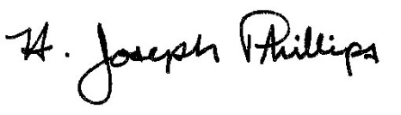 By:__H. Joseph Phillips___________

Title: __Historic Officer____________

Date of Meeting: November 7, 2018

